**“To serve others in need and help one another enjoy retirement.”**

September, 2020 Vol. 7 HELLO, SEPTEMBER!

The world outside my window is always a chronicle of the corn. The stalks are drying from the ground up now, and the ears are beginning to drop down. Couple that with cool nights and damp air and know that fall in Erie County is sliding into place. It is strange, however, to know school has begun and not hear buses braking every morning and afternoon to let the neighborhood youngsters pile in or out. All of us who have been so intimately connected to the educational process can easily imagine the challenges facing every school employee right now. A young friend of mine who drives bus is trying to imagine (when buses are running in Fairview) how her grade school charges will wear face masks without dropping, losing, or trading them! Think about it – they have always traded lunches, clothes, and, unfortunately, homework assignments.

We can be sure, however, that people will adapt and will discover ingenious ways to cope with the challenges they face. They always do. This brings to mind a movie that our grandsons wanted us to watch with them. This movie would never have been on our “must see” list, but I’d actually like you to add it to yours. The Croods is a classic tale of the older generation bucking change and the younger generation embracing it. The Crood family experiences a series of events that make young and old viewers laugh aloud, but like many animated films, the true message is aimed at the adult audience. The movie is entertaining, uplifting, and thought-provoking. It’s on Netflicks, and I’m sure you could find it in other places too. Other movies that have been brought to my attention are Rocket Man, The Joker, and A Beautiful Day in the Neighborhood. All come highly recommended so I’m putting them on my list for this winter!

While the governor’s guidelines remain as they are, we will not be meeting at the Shrine Club. We can continue to check in with friends and neighbors and brighten their day. We can also keep in touch with each other and share the things we’re using to stay engaged and upbeat. I have a few thoughts along that line. If your book club is still meeting, even if it’s a Zoom, consider sending a brief review of the group’s favorite books to Marty at reddingermartha@gmail.com. She can print these in the newsletter so others can learn about them. If you’ve found a game on your phone that has become your daily entertainment, let the rest of us know about it. If you’ve discovered an exercise maven who inspires you to work out, share the site so more of us can stay in shape this winter. If you’ve found the best walleye spot in Lake Erie, just email me quietly! Ok, I guess you’ll have to share that one too!

And finally, when the situation seems out of hand and the world keeps changing, remember what C.S. Lewis believed: “There are far, far better things ahead than any we may leave behind.”

From Our President, Connie Walker

**Welcome New Retirees!**

**Welcome to the wonderful world of Retirement! We hope you will consider joining us at PASR. For just $12.00 per year you can join the Erie County Chapter of PASR. We provide many social activities and ways of giving service to others.**

You can also join the State organization for an additional $60.00 per year. This membership gives you a voice in our state government as others fight to protect your pension. You are also eligible for many endorsed benefits, such as vision and dental. See our website, PASR.org, for more information.

For more information on joining, please contact your membership chairs.

Mary Hoffman at 814-873-2981 or Mary Ellen Lieb at 814-873-1284

**PASR Membership Update:**

**How do you know if you still owe dues for membership? Simple. . . . . .**if you received a notice in the mail at the end of August from us (Mary Hoffman and Mary Ellen Lieb), you owe chapter dues for the upcoming year. If you did not receive a notice in the mail, you are paid! Chapter dues are $12.00 per year. If you owe state dues, you are welcome to pay them when you send in your chapter dues to Mary Ellen.

**PASR LUNCH INFORMATION FOR 2019-2020**

To make a lunch reservation:

Sign up at a PASR luncheon for the following month’s lunch or

Call, test or email Pat Crist by the Friday prior to the lunch.

• Call (449-3509) and leave a message

• Text (449-3509)

• Email (pcrist331@yahoo.com)

Pat will respond to your message within 24 hours. If she doesn’t, please resend your message.

If you need a vegetarian meal, please tell Pat when you leave your message.

To cancel a lunch reservation:

If you made a lunch reservation and are unable to attend, please contact Pat Crist by the Friday prior to the lunch meeting. If you do not cancel your reservation, you will be billed $13.00 for the lunch that was ordered for you. See contact information above.

**LUNCH MENU—COST $13.00**

The lunch menu for this 2020-2021 year has been settled. We will let you know as soon as the meetings have been scheduled so that you can call or email Pat Crist to make your reservation.

**Benefits of Joining Erie County Chapter PASR**

* Continued fellowship
* Educational grants
* Legislative updates (ex. Concerning pension fund)
* Member benefits
* Monthly luncheon
* Recreational trips and outings
* Retirement planning seminars
* Social service outreach to members in need
* Volunteer opportunities

and much, much more!

**The Erie Chapter Website**

**Our updated website is ready for your inspection!**  Go to: <https://www.pasr.org/chapters/Erie>

The chapter will change the website as activities begin to happen so that you can abreast with the group. You can also tell friends who do not belong to our PASR chapter to check out our website! We are just waiting for things to open up again—hopefully soon!

**Need To Get In Touch?**

We are in this together! Give us a call for more information.

**PASR (717) 697-707**

**878 Century Drive**

**Mechanicsburg, PA 17055**

**Executive Director** Mark A. McKillop

**State President** Judith Schaffer

**Region 9 Director** Martha Reddinger

(814) 440-1795

**Erie Chapter President** Connie Walker

(814) 474-3563

**Corresponding Secretary** Joyce Mineo

Contact for cards (814) 838-9949

**Membership** Mary Hoffman (814) 866-1664

Mary Ellen Lieb (814) 868-1284

**SSMHF** Phyllis Rzodkiewicz (814) 868-0200

**Keep these names and phone numbers for your future reference.**



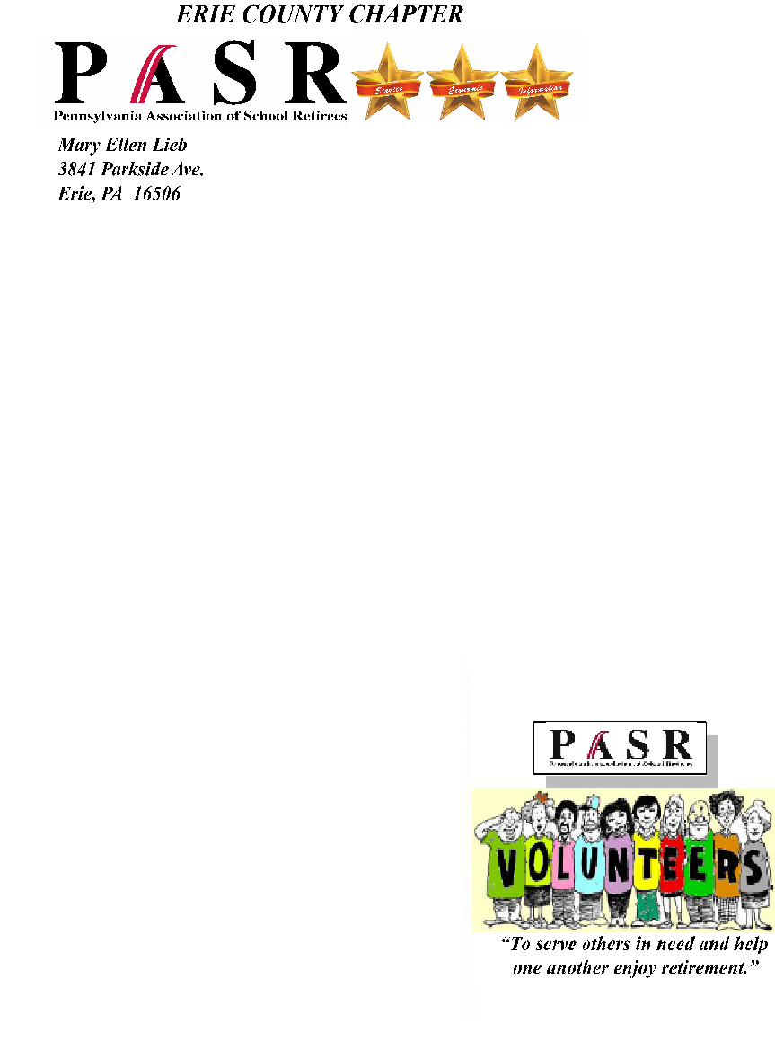

OBITUARIES FOR AUGUST, 2020

8/2/20 Virginia Irene Lundberg 8/3/20 Elaine E. Nejman

8/5/20 Barbara Shapiro 8/6/20 Maxine (Sopher) Ryder

8/6/20 Tillie C. Wilcox 8/8/20 Norma J. Wolfrom Siegel Henderson

8/11/20 Barbara Abegg 8/11/20 Miriam Ruth Miller McKinley

8/23/20 Geraldine E. Carey 8/24/20 Raymond Charles Gallagher

8/26/20 Bonita R. “Bon” Himrod 8/27/20 Doris E. (Fails) Perry Sherman

8/29/20 Sheila (Leninsky) Moreland 8/30/20 Susan F. Hedge

8/30/20 Agatha Veronica Florek Tyzinski 8/26/20 Frank Rinderle **

6/18/20 Anna May Vicchy

** Denotes membership in the Erie Chapter of PASR



[This Photo](http://commons.wikimedia.org/wiki/Summer) by Unknown Author is licensed under [CC BY-SA](https://creativecommons.org/licenses/by-sa/3.0/)

We send our love to the friends and family of these persons.